TYPES OF RELATIONSHIPS
Understanding the different types of relationships can help you appreciate the diverse connections in your life. Each type of relationship offers unique benefits and is vital to your overall well-being. Here, we explore various types of relationships and what makes them special.

Romantic Relationships
Characterized by emotional and physical intimacy. They often involve deep affection, love, and a commitment to a shared future.

Friendships
Voluntary relationships based on mutual liking, respect, and trust. They provide emotional support, companionship, and a sense of belonging.

Family Relationships
connections with people related by blood, marriage, or adoption. They provide a sense of identity, belonging, and unconditional support.

Professional Relationships
Formed in the workplace and are essential for career growth and job satisfaction. Based on mutual respect and collaboration.

Acquaintances
People you know but do not have a close relationship with. These connections can be pleasant and provide opportunities for networking.

ELEMENTS OF HEALTHY RELATIONSHIPS
Healthy relationships are built on several key elements that foster mutual respect, trust, and affection. Understanding these elements can help you nurture and strengthen your relationships. Here, we explore the essential components of a healthy relationship.

Communication
Involves openly expressing thoughts, feelings, and needs. It is the foundation of understanding and resolving conflicts.

Trust
The belief in the reliability, truth, and integrity of a person. It forms the basis of a secure and stable relationship.

Respect
Involves valuing each other's opinions, feelings, and boundaries. It is essential for maintaining harmony and mutual understanding.

Emotional Intimacy
Closeness that comes from sharing thoughts and feelings without fear of judgment. It strengthens the bond between individuals.

Physical Intimacy
Expressing affection through touch, such as holding hands, hugging, and other forms of physical closeness. It enhances emotional bonds.

Support
Means being there for each other in times of need, offering help, and providing encouragement.

DOMAINS OF INTIMACY
Intimacy is a crucial aspect of any close relationship, encompassing various domains that contribute to a deep and meaningful connection. Understanding these domains can help you nurture intimacy and strengthen your relationships. Here, we explore the different domains of intimacy.

Emotional Intimacy
involves sharing personal feelings, thoughts, and experiences. It fosters trust and a deep sense of connection.

Physical Intimacy
Includes expressing affection through touch, such as hugging, holding hands, and other forms of physical closeness.

Intellectual Intimacy
Involves sharing ideas, thoughts, and discussions on various topics. It builds a sense of mutual respect and understanding.

Experiential Intimacy
Built through shared activities and experiences that create lasting memories and strengthen the bond.

Spiritual Intimacy
Involves sharing beliefs, values, and practices related to spirituality or religion. It fosters a sense of unity and shared purpose.

COMMUNICATION SKILLS
Effective communication is the cornerstone of healthy relationships. It helps build trust, resolve conflicts, and deepen connections. Understanding and improving your communication skills can greatly influence the quality of your relationships. Here, we explore key communication skills that can enhance your interactions with

others.

Active Listening
Maintain eye contact
Avoid interrupting
Reflect back what you hear Show empathy

Empathy
Put yourself in the other person's shoes
Validate their feelings
Show genuine interest and concern
Offer support and understanding

Nonverbal Communication
Pay attention to your body language Use facial expressions to convey emotions Be mindful of your tone of voice
Notice the nonverbal cues of others

Conflict Resolution
Stay calm and composed
Focus on the issue, not the person
Use problem-solving strategies
Seek compromise and collaboration
Open-Ended Questions
Ask questions that start with "how,"
"what," or "why"
Encourage elaboration
Avoid yes/no questions
Show curiosity and interest

Clear and Honest Expression
Use "I" statements
Be specific and concise
Express feelings and needs openly
Avoid blame and judgment

TYPES OF ATTACHMENT STYLES
Attachment styles are patterns of connecting with others, often formed in childhood based on our early relationships with caregivers.

Secure Attachment
Individuals with secure attachment styles feel at ease with both intimacy and independence, fostering trusting relationships with effective communication and conflict resolution and maintaining a healthy balance of emotional and physical intimacy.

Anxious Attachment
Individuals with an anxious attachment style desire closeness but are apprehensive about abandonment. They often seek reassurance and may feel insecure in relationships, sometimes coming across as clingy or dependent.

Avoidant Attachment
Individuals with an avoidant attachment style value independence and selfsufficiency, find it challenging to connect intimately, may come across as emotionally distant, and are often reluctant to depend on others.

Disorganized Attachment
Individuals with a disorganized attachment style might exhibit a combination of anxious and avoidant behaviors, often experiencing fear of intimacy. Such individuals may encounter challenges in emotional regulation and maintaining stable relationships.

ATTACHMENT STYLE ASSESSMENT
Use this worksheet to assess your attachment style by reflecting on your relationship behaviors and answering the following questions. Number 1-5 for each question.
Question
I find it easy to get close to others.
I worry a lot about my relationships and whether people like me.
I am comfortable depending on others and having others depend on me.
I prefer not to show others how I feel deep down.
I often worry that my partner will not want to stay with me.
I feel uncomfortable when others get too close to me.
I trust others and don't worry much about being abandoned.
I have difficulty trusting others completely.
I am afraid of being too close to others.
I need a lot of reassurance from my partner.
I often feel that my partner doesn't care as much about me as I do about them.
I find myself pulling away when others try to get too close.
I feel confident that my partner will always be there for me.
I get uncomfortable when someone wants to be very close to me emotionally.
I am comfortable with being intimate and close with others.
I often feel that I am more invested in my relationships than others are.
Secure Attachment (Questions 1, 3, 7, and 15): Higher scores indicate a secure attachment style, characterized by comfort with intimacy and independence.
Anxious Attachment: (Questions 2, 5, 10, and 11): Higher scores indicate an anxious attachment style, characterized by a need for reassurance and fear of abandonment.
Avoidant Attachment: (Questions 4, 6, 8, 12, and 14): Higher scores indicate an avoidant attachment style, characterized by discomfort with closeness and dependence on others.
Disorganized Attachment: High scores in both anxious and avoidant areas may suggest a disorganized attachment style, which involves conflicting feelings about relationships.

COMMUNICATION STYLES
Understanding your communication style and that of your partner can significantly enhance your relationship. Use this worksheet to identify your communication styles, explore how they affect your interactions, and learn strategies to improve your communication. | Passive  Tends to avoid conflict, often does not express own needs or desires.  Aggressive  Expresses needs and desires forcefully, often at the expense of others.  Passive-Aggressive
Appears passive on the surface but expresses anger in subtle, indirect ways.

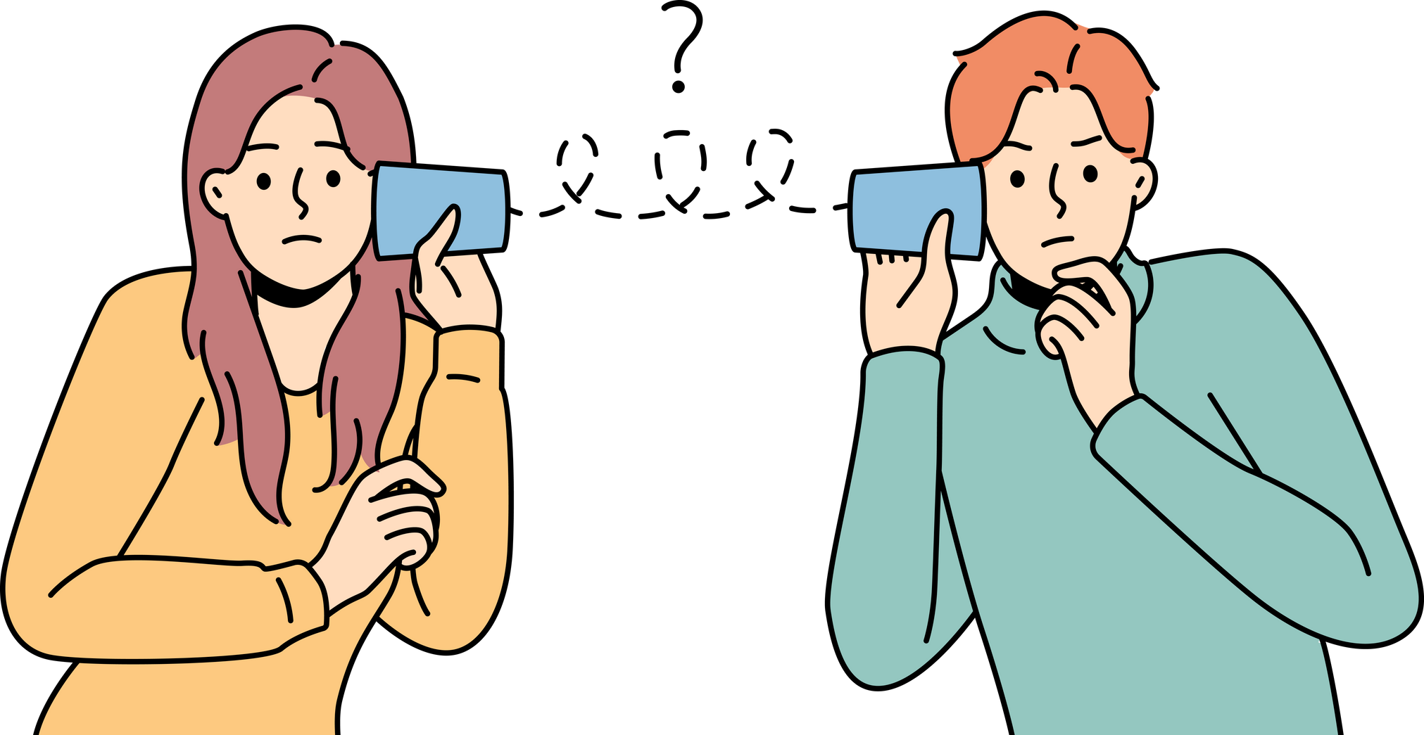
Assertive
Expresses needs and desires openly and respectfully, while also considering others’ needs and desires.

Impact
Reflect on how your communication styles impact your relationship. Use the space below to discuss and write down the positive and negative effects.

COMMUNICATION STYLE ASSESSMENT
Use this worksheet to assess your communication style by reflecting on your behaviors and answering the following questions. Number 1-5 for each question.
Question
I express my thoughts and feelings clearly and directly.
I avoid expressing my true feelings to avoid conflict.
I tend to dominate conversations and interrupt others.
I use sarcasm or indirect methods to express my feelings.
I listen actively and respect others' opinions.
I hesitate to speak up when something bothers me.
I raise my voice or use an angry tone when expressing my feelings.
I agree to things I don’t want to do to avoid upsetting others.
I communicate my needs and wants confidently.
I avoid eye contact and fidget when speaking.
I blame others for my problems and frustrations.
I use passive-aggressive behavior like giving the silent treatment.
I handle disagreements respectfully and seek a win-win solution.
I keep my opinions to myself to avoid conflict.
I use threats or intimidation to get my way.
I make sarcastic comments when I'm upset.
Assertive Communication (Questions 1, 5, 9, 13): Higher scores indicate an assertive communication style, characterized by clear, direct, and respectful expression.
Anxious Attachment: (Questions 2, 6, 8, 10, 14): Higher scores indicate a passive communication style, characterized by avoidance of expressing thoughts and feelings.
Aggressive Communication (Questions 3, 7, 11, 15): Higher scores indicate an aggressive communication style, characterized by dominating and confrontational behavior.
Passive-Aggressive Communication (Questions 4, 12, and 16): Higher scores indicate a passive-aggressive communication style, characterized by indirect and sarcastic expression of feelings.

